BELLA TREVINO

*WEB DEVELOPER*

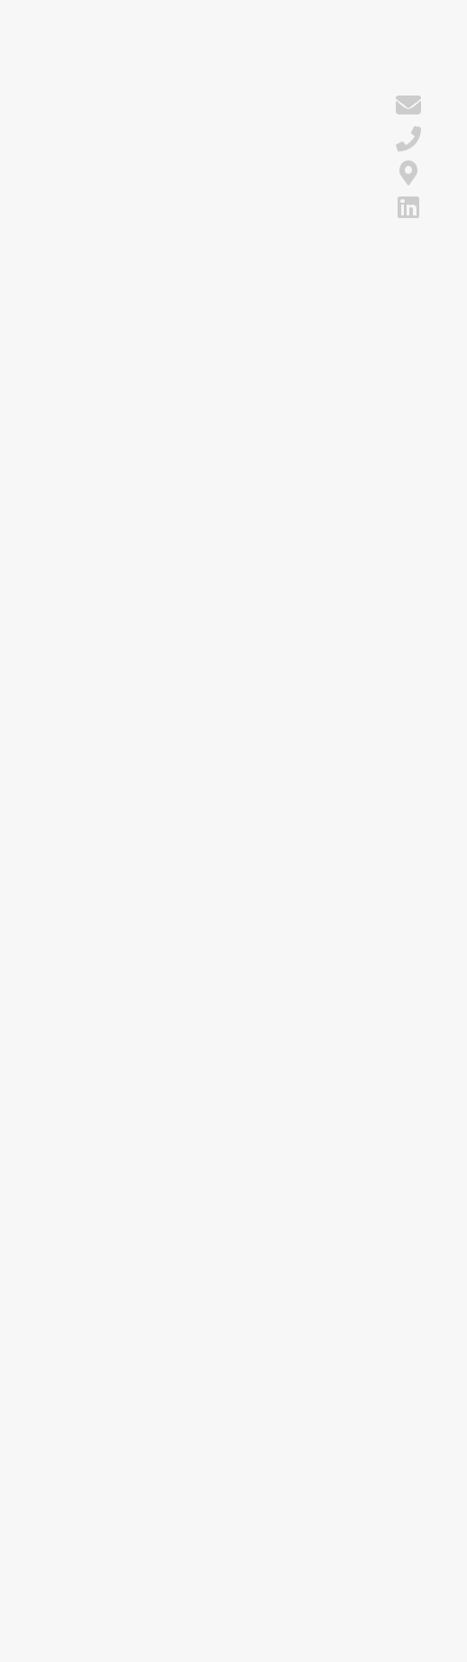

**CONTACT** **CAREER OBJECTIVE**

bellatrevino@email.com

1. 456-7890 Chicago, IL [LinkedIn](http://linkedin.com/in/bella-trevino)

**EDUCATION**

B.S.

Computer Science

University of Illinois

Chicago

2016 - 2020

Chicago, IL

GPA: 3.9

*Presidential Scholarship Cum Laude Society Dean's List (6/8 semesters)*

**SKILLS**

JavaScript (Angular)

HTML/ CSS

Python (Django)

SQL (PostgreSQL, Oracle)

REST APIs

Git

Graduate of computer science with experience working across the full-stack of software development. Looking for a role where I can grow and learn from experienced team members while drawing on project experience I have already successfully executed.

**WORK EXPERIENCE**

Web Developer Intern

Book of the Month

April 2019 - September 2019 / Chicago, IL

* Developed in-house web app using Node, React, and HTML/CSS that allowed employees to manage and recommend books
* Gathered user requirements, and built and maintained code for the tool, saving employees 14 monthly hours in labor
* Collaborated with 3 interns and senior developer to brainstorm and implement ideas and feedback into app's development
* Selected as the top performing intern by the technology team

**PROJECTS**

Social Media Scheduler

Creator

* Built responsive app using Django and Node that allowed users to schedule social media posts across Instagram and Twitter
* Built features using scikit-learn in Python that learned the time of day of maximum engagement with social media posts, which increased overall engagement rate by 23% for users
* Released it for free for University of Illinois Chicago students, and it quickly grew to over 500 monthly active users
* Featured across 7 local newspapers, radio stations, and news networks with focus around use of Twitter and Instagram APIs

Computer Science Club

Co-founder

April 2017 - April 2020

* Presented a need for a computer science club to student government, obtained club approval, and secured club advisor
* Co-founded the computer science club at the University of Illinois Chicago to encourage exchanges among CS students surrounding new concepts and technical problems
* Led club members to spend 2 hours a week pair programming with another member to share learnings
* Partnered with journalism majors to attract 35 active members to the club in frst year, using web and tv campaigns